Hello all,  
 As promised, here is a more comprehensive description of the project, who I am, what I’m looking for in a research assistant, and a basic timeline. Good luck getting through it all, and I look forward to hearing from any/all of you who might still be interested after reading the details…

Cheers,  
Julian (Vinay) Kapoor

---

About me:  
 I am a postdoctoral researcher of animal behavior at Cornell, based at the Lab of Ornithology, and, as you know, I am looking for assistance with a project involving the development of an automated telemetry system for tracking small free-living animals. For my graduate work at Cornell in the department of Neurobiology and Behavior I studied the breeding behavior of an extremely small hummingbird (the little hermit) on the island nation of Trinidad. As part of my research it was important that I locate the nests of these birds, however, because these nests are extremely difficult to locate visually I had to find a way to find nests using other means. Telemetry (i.e. tracking animals fitted with radio transmitters) appeared to be an attractive solution, but no radiotransmitters were commercially available that were small enough to be carried by the birds (the US government stipulates that no device can be fitted on a wild bird that exceeds 5% of the weight of that bird, in this case a 150 mg tag would be required). If I wanted to track these birds I would have to make these radiotags myself. Because I had only a background in biology, not engineering, I had to spend a good deal of time learning much of the basics of radio electronics, but I was ultimately able to create tags that worked for this purpose. See the picture of a little hermit fitted with one of these radiotags below:

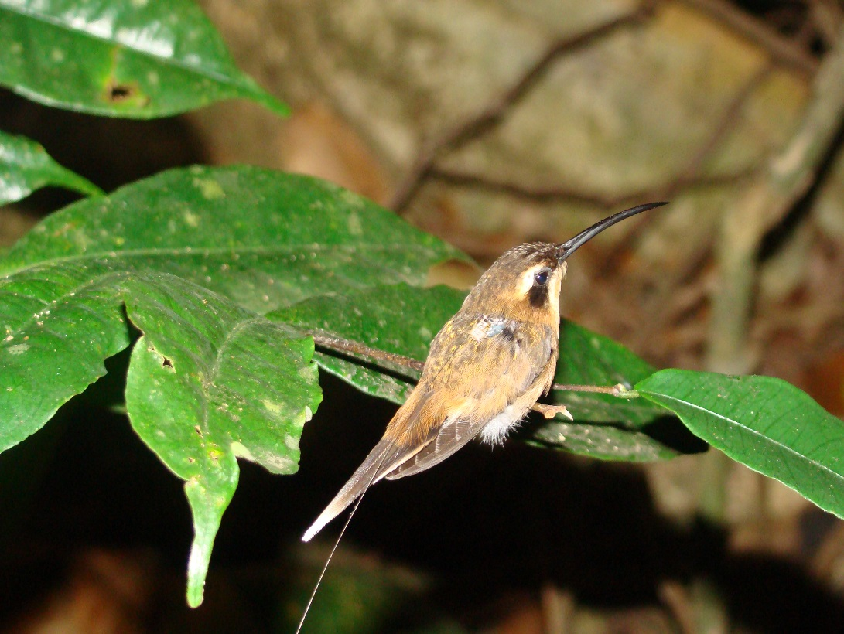

Since completing my graduate work I have moved on to a postdoctoral position at the Lab of Ornithology, where I am conducting a study on a small Australian bird (the red-backed fairywren), which is only slightly larger than the little hermit (~7 g). These birds are interesting, in part, because males of this species spend much of their lives as dull-colored individuals (see the picture below, photo credit T. Ashton) with low chances of obtaining a mate, but when they molt into bright plumage (the black individual with red feathers) their reproductive success drastically improves. The curious thing about this situation is that the timing of this molt in the non-breeding season (i.e. how early in the year the male begins to transition from dull to bright) predicts how well males do later during the breeding season in a different fairywren species, and likely in this one as well. Males go around during the non-breeding season showing off their plumage and singing to females. What this means is that females must be paying attention to which males molt early, and remembering who these males are. The goal of my postdoctoral project is to understand how females identify individual males in the pre-breeding season. Unfortunately, following these birds is extremely difficult since they are very mobile, and recording their songs is even more challenging because they are wary of researchers who approach close enough to record them.

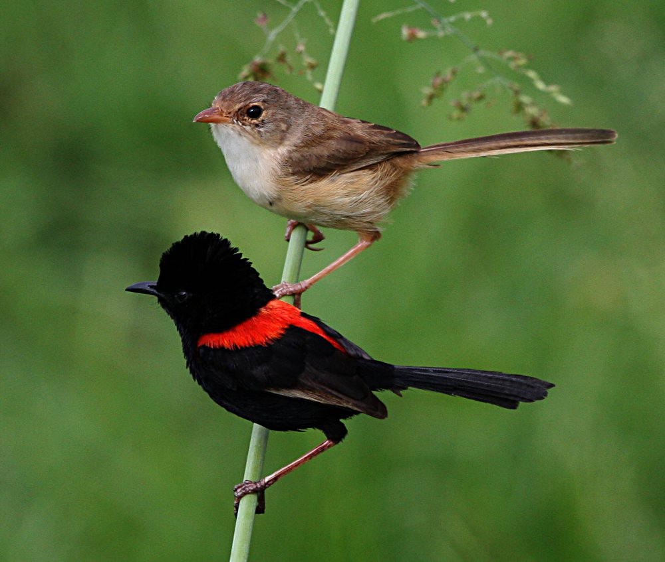

Both of these technical difficulties could potentially be resolved with telemetry technology, so I am continuing to develop my transmitters for use with these birds. Although I have a clear vision of the type of telemetry system I would like to deploy to study these birds in Australia (description below), I have reached the limit of my understanding of telemetry technology; which is why I am seeking smart, motivated engineering students to help me to continue developing an appropriate telemetry system.

The telemetry system (i.e. the project):  
 There are two primary aspects of the telemetry system that I am hoping to develop to study the social behavior of red-backed fairywrens: 1) an automated triangulating receiver network and 2) light-weight radio transmitters capable of both transmitting their ID and acoustic data (when prompted to do so). Note that much of the details (and possibly even some of the basic building blocks) may change as a result of input from the engineering students working with me on this project.

1) The receiver network:

A major challenge for wildlife radio tracking is in obtaining high-accuracy position data of multiple individuals in a population. Most tracking technology used today by wildlife biologists involves the use of 1-3 researchers tracking animals while on foot (or by vehicle). This approach typically results in low-accuracy position information of just a few individuals for a relatively short period of time. A far better approach would be automated tracking of multiple individuals from a network of receivers on stationary towers. Such automated systems exist – for instance the Automated Radio Telemetry System (ARTS) at Barro Colorado Island in Panama (this systems is now defunct) – but suffer from a number of setbacks. First, most existing systems use multiple antennas to create an estimate of location based on the received strength of a signal from 3 or more receiver towers. This requires bulky and expensive receiver modules, and results in fairly imprecise location data. More recent work in automated telemetry has focused on the use of GPS technology to increase position accuracy. Unfortunately, GPS technology is still far too bulky for many small organisms (including the fairywrens) and is similarly very expensive. Other efforts to create receiver networks have begun to develop the use of Time Difference of Arrival (TDOA) systems. Although these systems have great promise, they require extremely broadband signals (difficult to achieve with bare-bones transmitters), and are also limited in the degree of precision they can obtain (RF signals travel so quickly that it is highly improbable that a practical receiver network would be able to resolve animal locations beyond ~20-30 m).

A less well-known (at least to biologists) alternative to TDOA for radio direction finding (DF) is a technique that has been used by the military for a very long time, known as Phase Interferometry for use in estimating the Angle of Arrival (AOA) of radio signals. Unlike TDOA systems, the accuracy of AOA systems scales strongly with the spatial scale of the receiver network. For instance, 10 receivers spread over 10 square kilometers might result in location estimates of +/-200 m, whereas the same number of receivers placed over 1 square kilometer might result in an accuracy of +/-20 m. Because many researchers are interested in small-scale movements of animals within populations, such a system may be extremely useful. I have therefore chosen to begin developing work on an AOA-based automated radio telemetry system.

Although I won’t get into all of the technical details now, the basic components of this system will likely be (vaguely) similar to the block diagram I’ve included below. The vast majority of the effort will be concentrated on the lower left and right blocks (i.e. the DF architecture, and datalogging). Briefly, the DF aspect of the receivers I am hoping to develop will use 2-3 dipole antennas to receive RF packets from radio tags transmitting at a carrier frequency of ~150 MHz (low frequencies transmit better through the environment, especially in the presence of vegetation). The use of low frequencies for transmissions means that estimating the phase of signals may be very difficult with relatively closely-spaced antennas (<< 1 wavelength). There is some interesting work demonstrating that this problem can be solved by coupling two antennas together in a way that mimics the neural structure of a type of parasitic fly (*Ormia ochracea,* a fly which can accurately localize the source of low frequency sounds based on phase differences of signals received by its two very closely spaced ears). The other aspects of this DF system - a low noise amplifier, mixer, and local oscillator (LO) to boost the received signal and mix it with the LO, an RF demodulator to enable the estimation of differences in phase between the received signals, and ADC ICs – are all fairly typical components of this kind of system, though significant work will be required to get accurate and precise AOA estimates. Signal detection and identification, triangulation (possibly only if receivers have access to the data from other receivers), and datalogging will all also require significant input from experienced engineers.

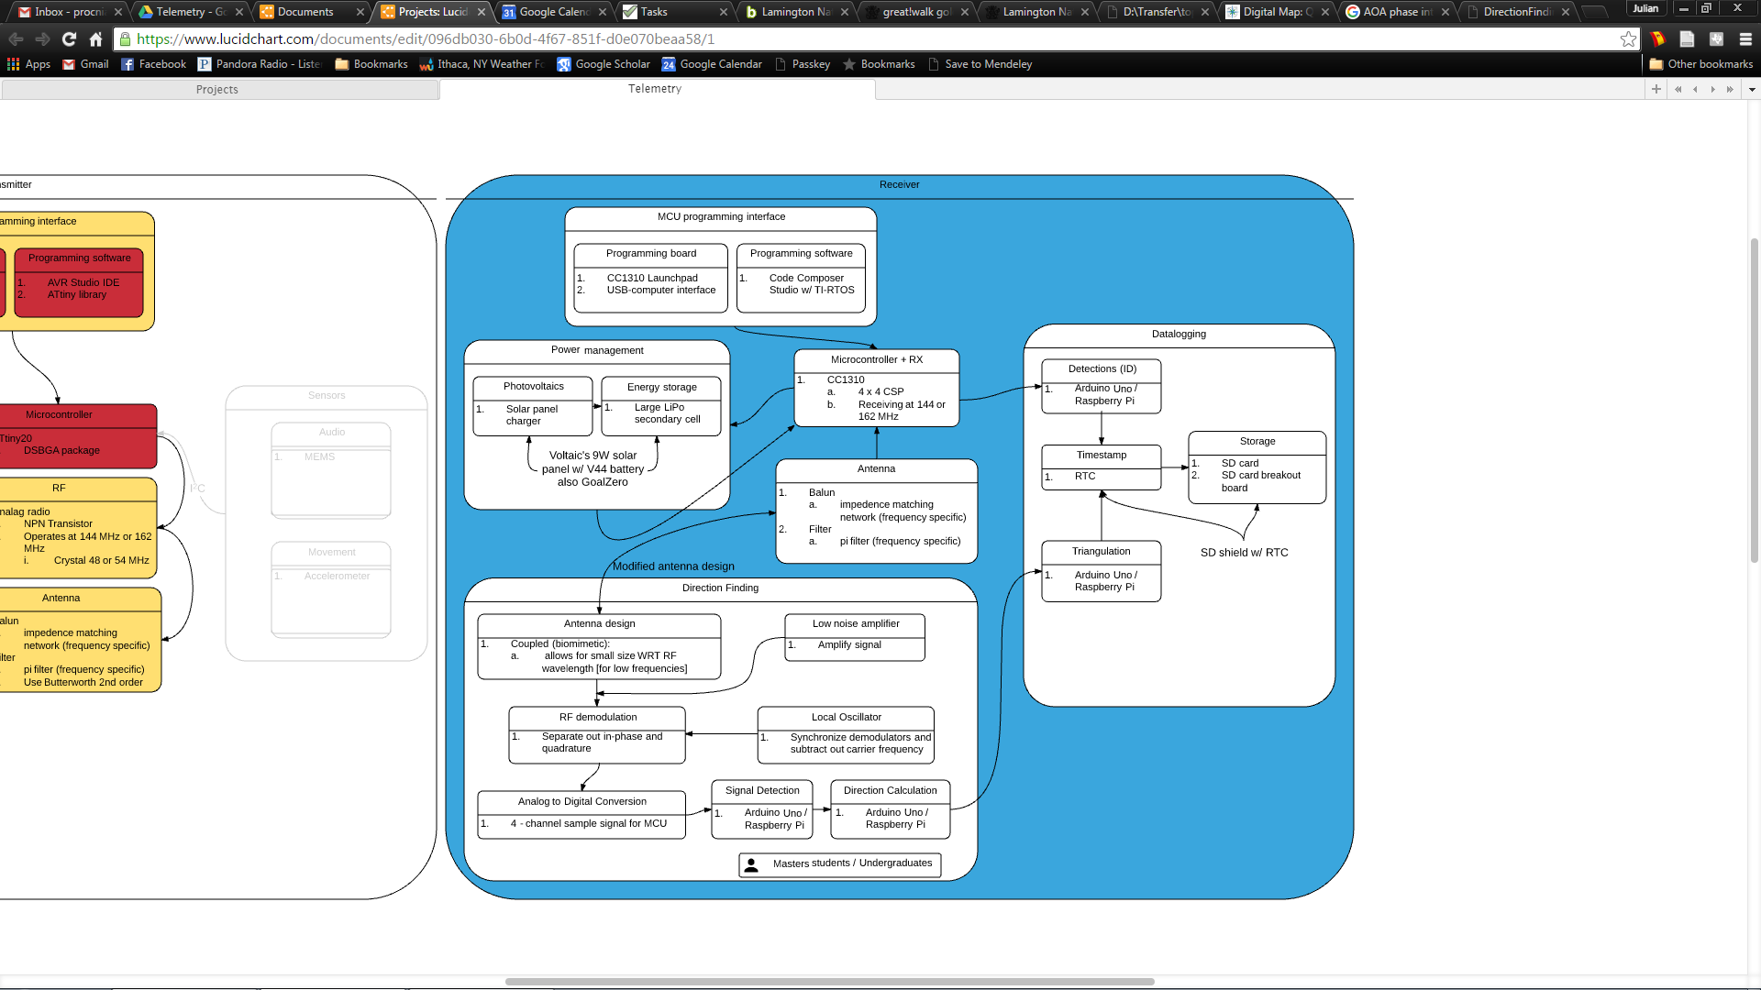  
2) The transmitters:

Without small, energy-efficient transmitters, the receiver network cannot be put to use for small bodied species of animals. Until very recently, most wildlife telemetry devices were transmitters (i.e. they could only transmit) that signaled only the animal’s identity, or very crudely encoded one or two types of information (like temperature, or activity levels). The boost in development of small, energy-efficient ICs for telecommunications has now made it possible to create radio transceivers that efficiently (and digitally) encode many types of physiological data on free-living animals and that can be given instructions remotely. Unfortunately, the majority of small radio transmitters on the market today are still far too large for use with animals like fairywrens.

The first goal for the transmission-side of the fairywren telemetry project is to create a small, energy efficient radio tag capable of communicating with the receiver network. Although this may sound like a relatively simple task, the constraints on the final weight of the tag – 350 mg – will make this a deceptively challenging task. Once we have a working “beeper tag” the next step is to add in the ability to transmit audio data received by a MEMS microphone that is integrated into the tag, while staying below the 350 mg weight budget. Although I would ultimately like to make the automated receiver network capable of receiving audio data, the first step will be to create a simple hand-held transceiver for this purpose. Because the tags must be extremely small, we will have to consider the possibility of energy-harvesting solutions to extend battery life. Also, because transmitting audio data will require that the transceiver IC be in active mode (very energetically expensive) it will be important that the tags transmit audio data only when the receiving transceiver is within range (meaning the tag must be able to listen for a targeted wake-up command from it), and when the bird is vocalizing (the tag must transmit data only when the input from the MEMS mic exceeds a certain threshold). Yet another complication is the possibility that multiple birds may be singing at once (in many cases the birds will be duetting), which may require that each tag sends audio data on a different frequency (and this frequency must be selectable by the hand-held transceiver so that conflicts can be avoided with other tags). Again, not so simple.

Your role:  
 So these are the two interconnected aspects of this telemetry project for which I am hoping to receive significant help with developing. This will be the first time that I have worked with and managed a group of engineering students, so it is hard for me to predict exactly how things will work out, but the following is my best guess should you end up working on either project:

1. We will meet weekly (or possibly once every two weeks) to discuss both projects. These meetings will mostly be a venue for all of us to discuss progress we’ve made, to share thoughts or ideas about modifications to the design of the receivers and/or transmitters, to troubleshoot problems together, and to make plans for the responsibilities and workload for all of us for the following week.
2. Each student (there will mostly likely be two on the receivers and two on the transmitters) will work mostly independently on a clearly-defined task that we decide upon during our meetings each week, though there will often be a need for significant coordination and collaboration with the other student working on your subproject.
3. Since I have practically no background in engineering, my primary role will be to coordinate our efforts, to purchase materials, to advise about the constraints on the design of the system, and to offer whatever guidance and assistance I’m able to. I will also make an effort to provide access to any resources (e.g. equipment and facilities) necessary, though my access to some types of instrumentation is limited. I would strongly encourage you to seek out expert advice from your own department when the need arises since I will not be able to help guide you through much of the technical challenges we’re likely to face.
4. In order for me to effectively coordinate our efforts I will also need you to be able to communicate your ideas with me in less technical language than you may be used to using among your ECE colleagues.

What’s in it for you?  
 Although assisting me with this project is likely to be a very different experience from the more structured internships or research assistantships you may be familiar with, it is my hope that this experience will benefit you in a number of ways.   
 First and foremost, if you work on either of the two projects you can and should apply to receive research credit for your assistance. Your efforts will be a combination of independent research and collaborative work with other engineers, as well as with biologists, and would therefore be a great thing to add to your CV or resume. I am currently looking in to the procedure for ECE students to do this, but encourage you to seek out this information as well. I will keep you informed of anything I learn regarding research credit.  
 Second, I have discovered that there is a large amount of variability in the abilities of professional engineers to understand and respond to real-world constraints, especially those that field biologists are faced with. I believe that the experience you will gain from designing a telemetry system in collaboration with a non-engineer will be vital as you move forward in your career. Ideally you will gain significant experience accommodating the biological constraints of the fairywren study system (e.g. weight limitations for tags, available sunlight for energy harvesting, low amplitude of fairywren song for MEMS microphones) on the technology we develop, and you will also gain plenty of experience thinking about possible alternative solutions for technical problems we come across, and testing which design rules/guidelines can be bent (or broken).  
 Third, it is my goal to make the technical details of the telemetry system we create freely available (i.e. open-source) to the scientific community for replication and further development by other researchers and engineers. The best way to do this is to write up one or more scientific journal articles detailing the specifications of the receiver network and the radio tags. If you provide significant input on the design of either project you will have the option to take part in helping to write an article (or articles) for a peer-reviewed journal and will be included as a coauthor.

Who I’m looking for:

1. As I’m sure you’re aware by now, both of these projects will require significant time investment on everyone’s part. If you join the research group you must be responsible for completing the tasks you take on to the best of your ability. I understand that your level of involvement may fluctuate from week to week as prelims and project assignments come up, and this is fine, but you must be willing and able to honestly indicate the amount of time and effort you will be willing to invest on the whole. You should also not sign up for more responsibilities during our weekly meetings than you are prepared to take on.
2. The projects I have outlined will entail more work than will fit into a single semester. Because of this I am hoping to find students who can commit to helping out during both the current (Fall) and the following (Spring) semesters. I am happy to have students who can commit to only one semester, but you must be sure to very carefully document your work so that whoever continues where you left off will be able to understand what you did and how you did it.
3. I am particularly interested in working with students who are specifically interested in contributing to biological applications of instrumentation, and/or those with an interest in radio electronics, or in sensor technology. If you are simply looking for some research experience to put on your CV you may quickly grow tired of working on this project if you do not also have a strong interest in the work itself. Please consider this carefully when deciding whether you are still interested. Incidentally, it is often as difficult to write a strong letter of recommendation for a student who has joined a project to pad their CV as it is easy to write a glowing recommendation for a student who is genuinely interested in the work.
4. Although I am happy to consider taking on any student with a background in ECE and an interest in the topics I’ve touched upon above, there are a number of specific technical skillsets that may be extremely useful as the project continues. These include (but are not limited to): experience programming in Matlab and/or Simulink, experience with Github (we will use this to manage the project’s files), background in RF electronics including topics like electronic filter design, signal processing, and antenna theory, experience with energy harvesting technologies, power management, embedded systems, experience working with Arduino/Raspberry Pi/BeagleBone devices.

How to “apply”

I have received a handful of inquiries from interested people already, and it is unlikely that I will be able to manage a team of more than 4 students. That likely means I won’t be able to take on everyone who is interested in this project. That said, if anyone who is accepted for the fall semester is unable to stay on for the spring semester, or decides not to continue at that point, I would be happy to consider applicants for the spring semester.  
 Here are the things you can do to help me if you would like to be considered for a research assistanceship:  
1) Transcript (unofficial is fine) - or - list of coursework and grades. \*Several of you have already provided this and there’s no need to send it again  
2) A brief statement of how this project fits your interests and or career goals. If you have any background that you think may be relevant, whether I’ve mentioned it above or not, please let me know. \*Again, several of you have already indicated this, so no need to repeat  
3) CV or resume if you have one and have not already sent it  
4) Questions for me! I fully expect that you may have questions about a number of things, and you may see an opportunity or problem that I have not, so please feel free to ask anything that comes to mind.

Thank you again for your interest in the project!

Cheers,

Julian